CAPTION SHEET

Shots | Caption
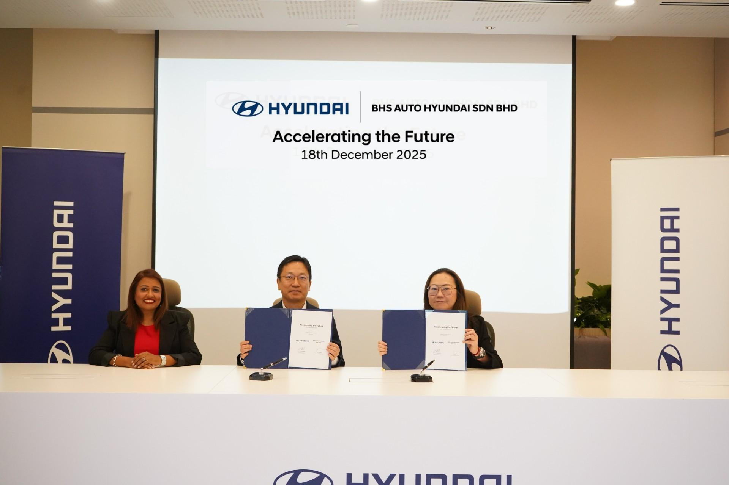 | BHS Auto Hyundai Sdn Bhd  (From L-R):  - Ms Jahabarnisa Haja Mohideen, Managing Director of Hyundai Motor Malaysia (HMY)  - Mr Eric Lee, President of Hyundai Motor Malaysia (HMY)  - Ms Kym Laoe, Director of BHS Auto Hyundai Sdn Bhd
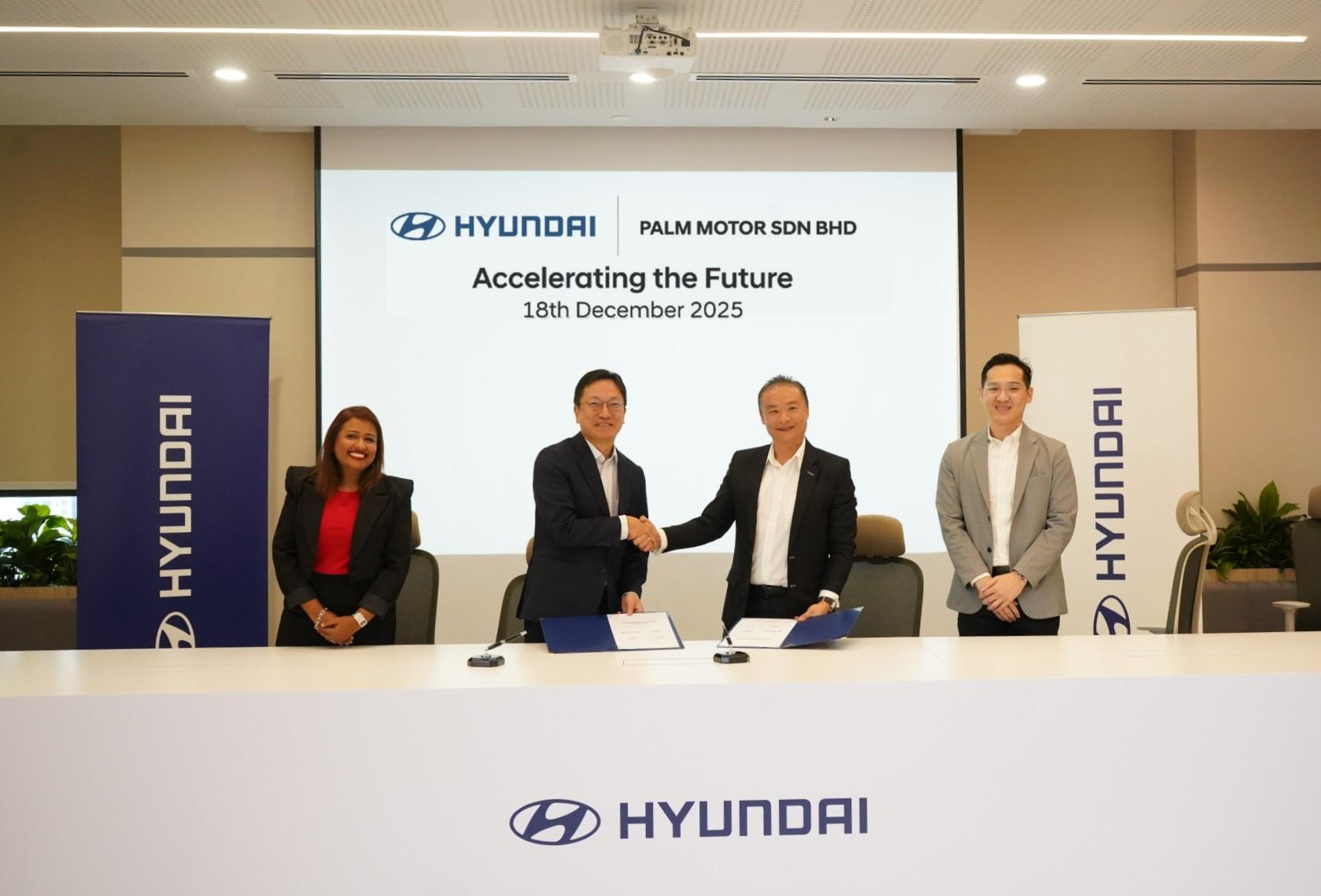 | Palm Motor Sdn Bhd  (From L-R):  - Ms Jahabarnisa Haja Mohideen, Managing Director of Hyundai Motor Malaysia (HMY)  - Mr Eric Lee, President of Hyundai Motor Malaysia (HMY)  - Mr Cedric Choo, Dealer Principal of Palm Motor Sdn Bhd  - Mr Jeremy Liew, Sales Manager of Palm Motor Sdn Bhd
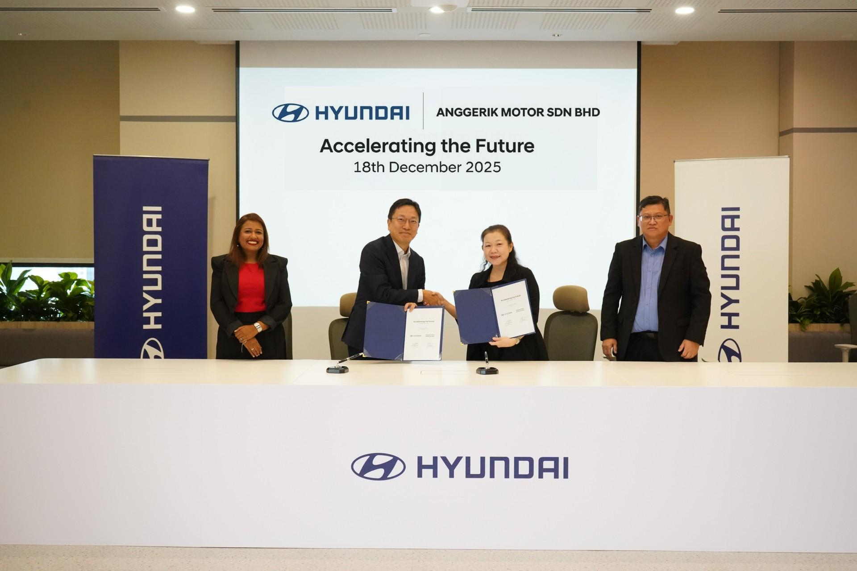 | Anggerik Motor (Senai) Sdn Bhd  (From L-R):  - Ms Jahabarnisa Haja Mohideen, Managing Director of Hyundai Motor Malaysia (HMY)  - Mr Eric Lee, President of Hyundai Motor Malaysia (HMY)  - Ms Chai Ee Ting, Executive Director of Anggerik Motor (Senai) Sdn Bhd  - Mr David Leong, Chief Executive Officer of Anggerik Motor (Senai) Sdn Bhd
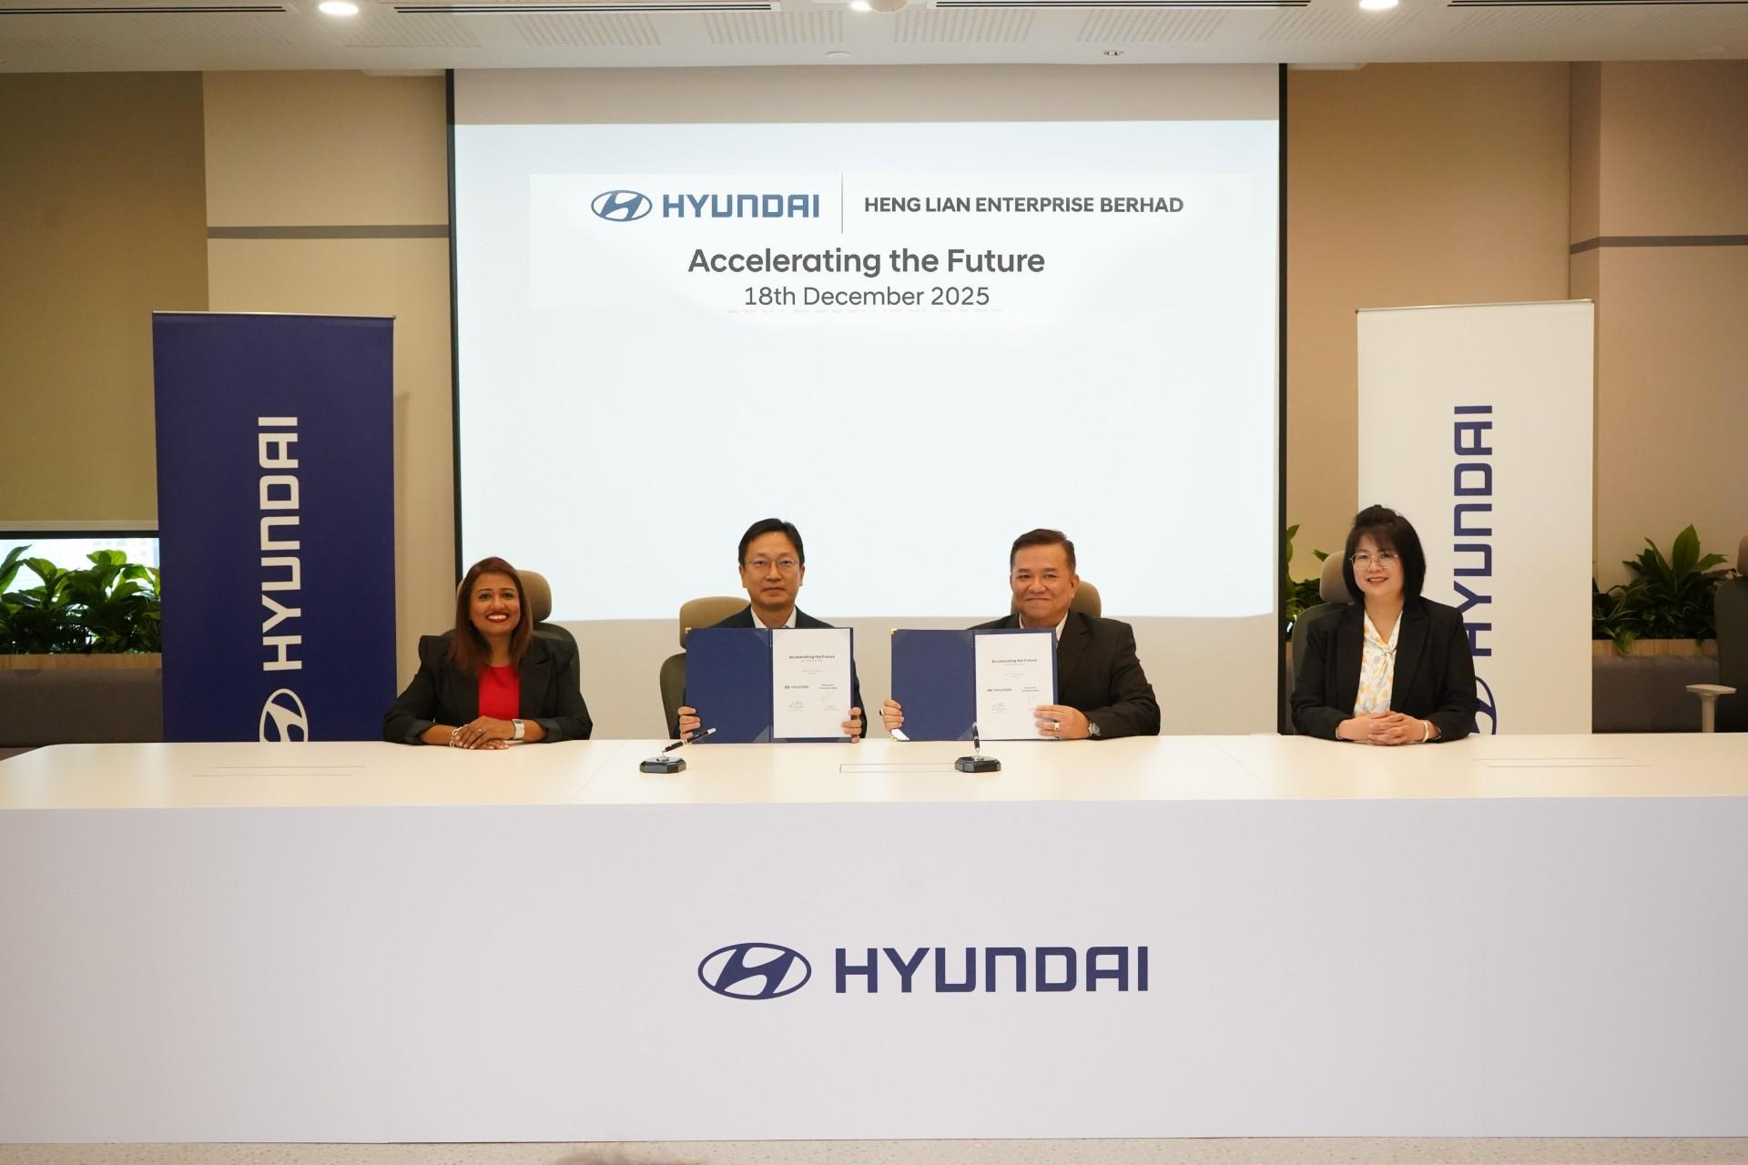 | Heng Lian Enterprise Bhd  (From L-R):  - Ms Jahabarnisa Haja Mohideen, Managing Director of Hyundai Motor Malaysia (HMY)  - Mr Eric Lee, President of Hyundai Motor Malaysia (HMY)  - Mr Kevin Law, Managing Director of Heng Lian Enterprise Bhd  - Mdm Sylvia Ng, Dealer Principal of Heng Lian Enterprise Bhd
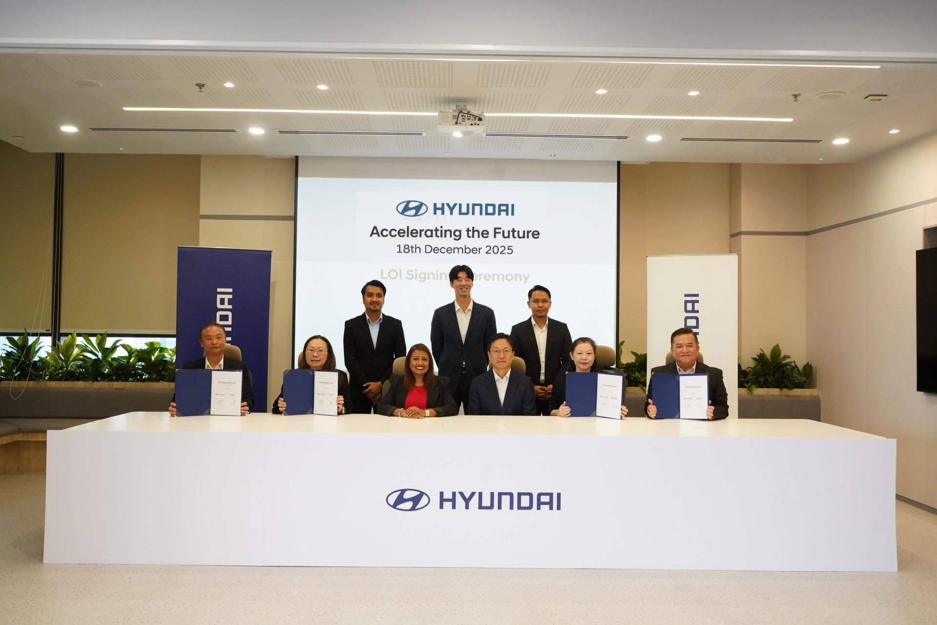 | Executive representatives from Hyundai Motor Malaysia and its newly appointed dealer partners coming together to commemorate a key milestone in Hyundai’s long-term expansion strategy in Malaysia, focused on accessibility, service excellence, and sustainable growth.  (Seated from L-R):  - Mr Cedric Choo, Dealer Principal of Palm Motor Sdn Bhd  - Ms Kym Laoe, Director of BHS Auto Hyundai Sdn Bhd  - Ms Jahabarnisa Haja Mohideen, Managing Director of Hyundai Motor Malaysia (HMY)  - Mr Eric Lee, President of Hyundai Motor Malaysia (HMY)  - Ms Chai Ee Ting, Executive Director of Anggerik Motor (Senai) Sdn Bhd  - Mr Kevin Law, Managing Director of Heng Lian Enterprise Bhd  (Standing from L-R)  - Mr. Mohd Haniff Zulaidi, Head of Channel Operation of Hyundai Motor Malaysia (HMY)  - Mr. Daniel Lim Jaehyun, Channel Coordinator of Hyundai Motor Malaysia (HMY)  - Mr. Syazzuan Bin Sazali, Head of Channel Strategic Planning of Hyundai Motor Malaysia (HMY)

